Class Design - Dock

# Create Initial Design Classes

# Define Relationships Between Classes

# Class Design

## Class “DockScreenHandler”

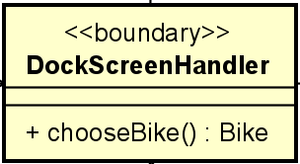

**Attribute**

None

**Operation**

|  |  |  |  |
| --- | --- | --- | --- |
| # | Name | Return type | Desciption |
| 1 | chooseBike | Bike | forward bike to the BikeScreenHandler |

Parameter:

None

Exception:

None

**Method**

None

**State**

None

## Class “DockScreenController”

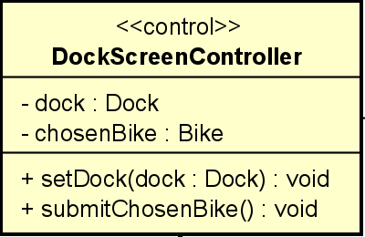

**Attribute**

|  |  |  |  |  |
| --- | --- | --- | --- | --- |
| # | Name | Data type | Default value | Description |
| 1 | dock | Dock | NULL | store the dock it works with |
| 2 | chosenBike | Bike | NULL | the bike user chooses from UI |

**Operation**

|  |  |  |  |
| --- | --- | --- | --- |
| # | Name | Return type | Desciption |
| 1 | setDock | void | set value for dock |
| 2 | submitChosenBike | void | send the chosen bike to other object |

Parameter:

dock – the dock instance

Exception:

None

**Method**

None

**State**

None

## Class “Dock”

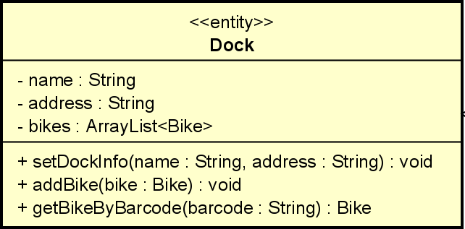

**Attribute**

|  |  |  |  |  |
| --- | --- | --- | --- | --- |
| # | Name | Data type | Default value | Description |
| 1 | name | String | NULL | name of the dock |
| 2 | address | String | NULL | location of the dock |
| 3 | bikes | ArrayList<Bike> | empty ArrayList | all available bikes |

**Operation**

|  |  |  |  |
| --- | --- | --- | --- |
| # | Name | Return type | Desciption |
| 1 | setDockInfo | void | update dock |
| 2 | addBike | void | add new bike to dock |
| 3 | getBikeByBarcode | Bike | search bike by barcode |

Parameter:

name – name of the dock

address – dock’s address

bike – the bike instance

barcode – bike’s barcode

Exception:

None

**Method**

None

**State**

None

## Class “DockList”

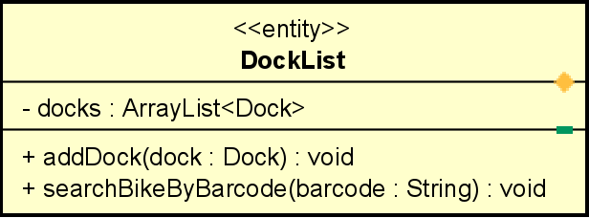

**Attribute**

|  |  |  |  |  |
| --- | --- | --- | --- | --- |
| # | Name | Data type | Default value | Description |
| 1 | name | String | NULL | name of the dock |

**Operation**

|  |  |  |  |
| --- | --- | --- | --- |
| # | Name | Return type | Desciption |
| 1 | addDock | void | add new Dock |
| 2 | searchBikeByBarcode | Bike | search and return bike with matching barcode |

Parameter:

dock – dock’s instance

barcode – the string barcode of a bike

Exception:

None

**Method**

None

**State**

None

# Class Diagram